HILLY FIELDS FOOTBALL CLUB
SEASON 12: 1978-79
RESERVES:
BECKENHAM LEAGUE:
P W D L F A Pts Pos
Division 3 20 6 4 10 47 52 16 8th
Beckenham League Cup 1 0 0 1 0 4
Beckenham Hospital Cup
Burwood Cup 1 1 0 0 3 2
Friendly 2 0 1 1 1 10
Apps Gls Apps Gls
Terry Bellinger 7 4 Dave Green 3 0
Bruce Burroughs 5 0 Malcolm Hill 1 0
Tony Byford 2 0 Bobby James 0 0
Chris Champ 1 0 Graham Mara 1 1
Colin Chandler 8 1 Mickey Michalle 7 0
Robin Cockle 8 0 Luis Navarro 6 1
Paul Cowdrey 1 0 Derrick Pankhurst 1 1
Steve Dolan 6 2 John Purdy 6 2
Paul Eustace 5 1 Ken Ridgway 7 0
Sabino Favorito 6 0 Barry Rowlands 2 1
Martin Formosa 5 0 Phil Webb 3 0
Keith Foster 5 0 Gary West 2 0
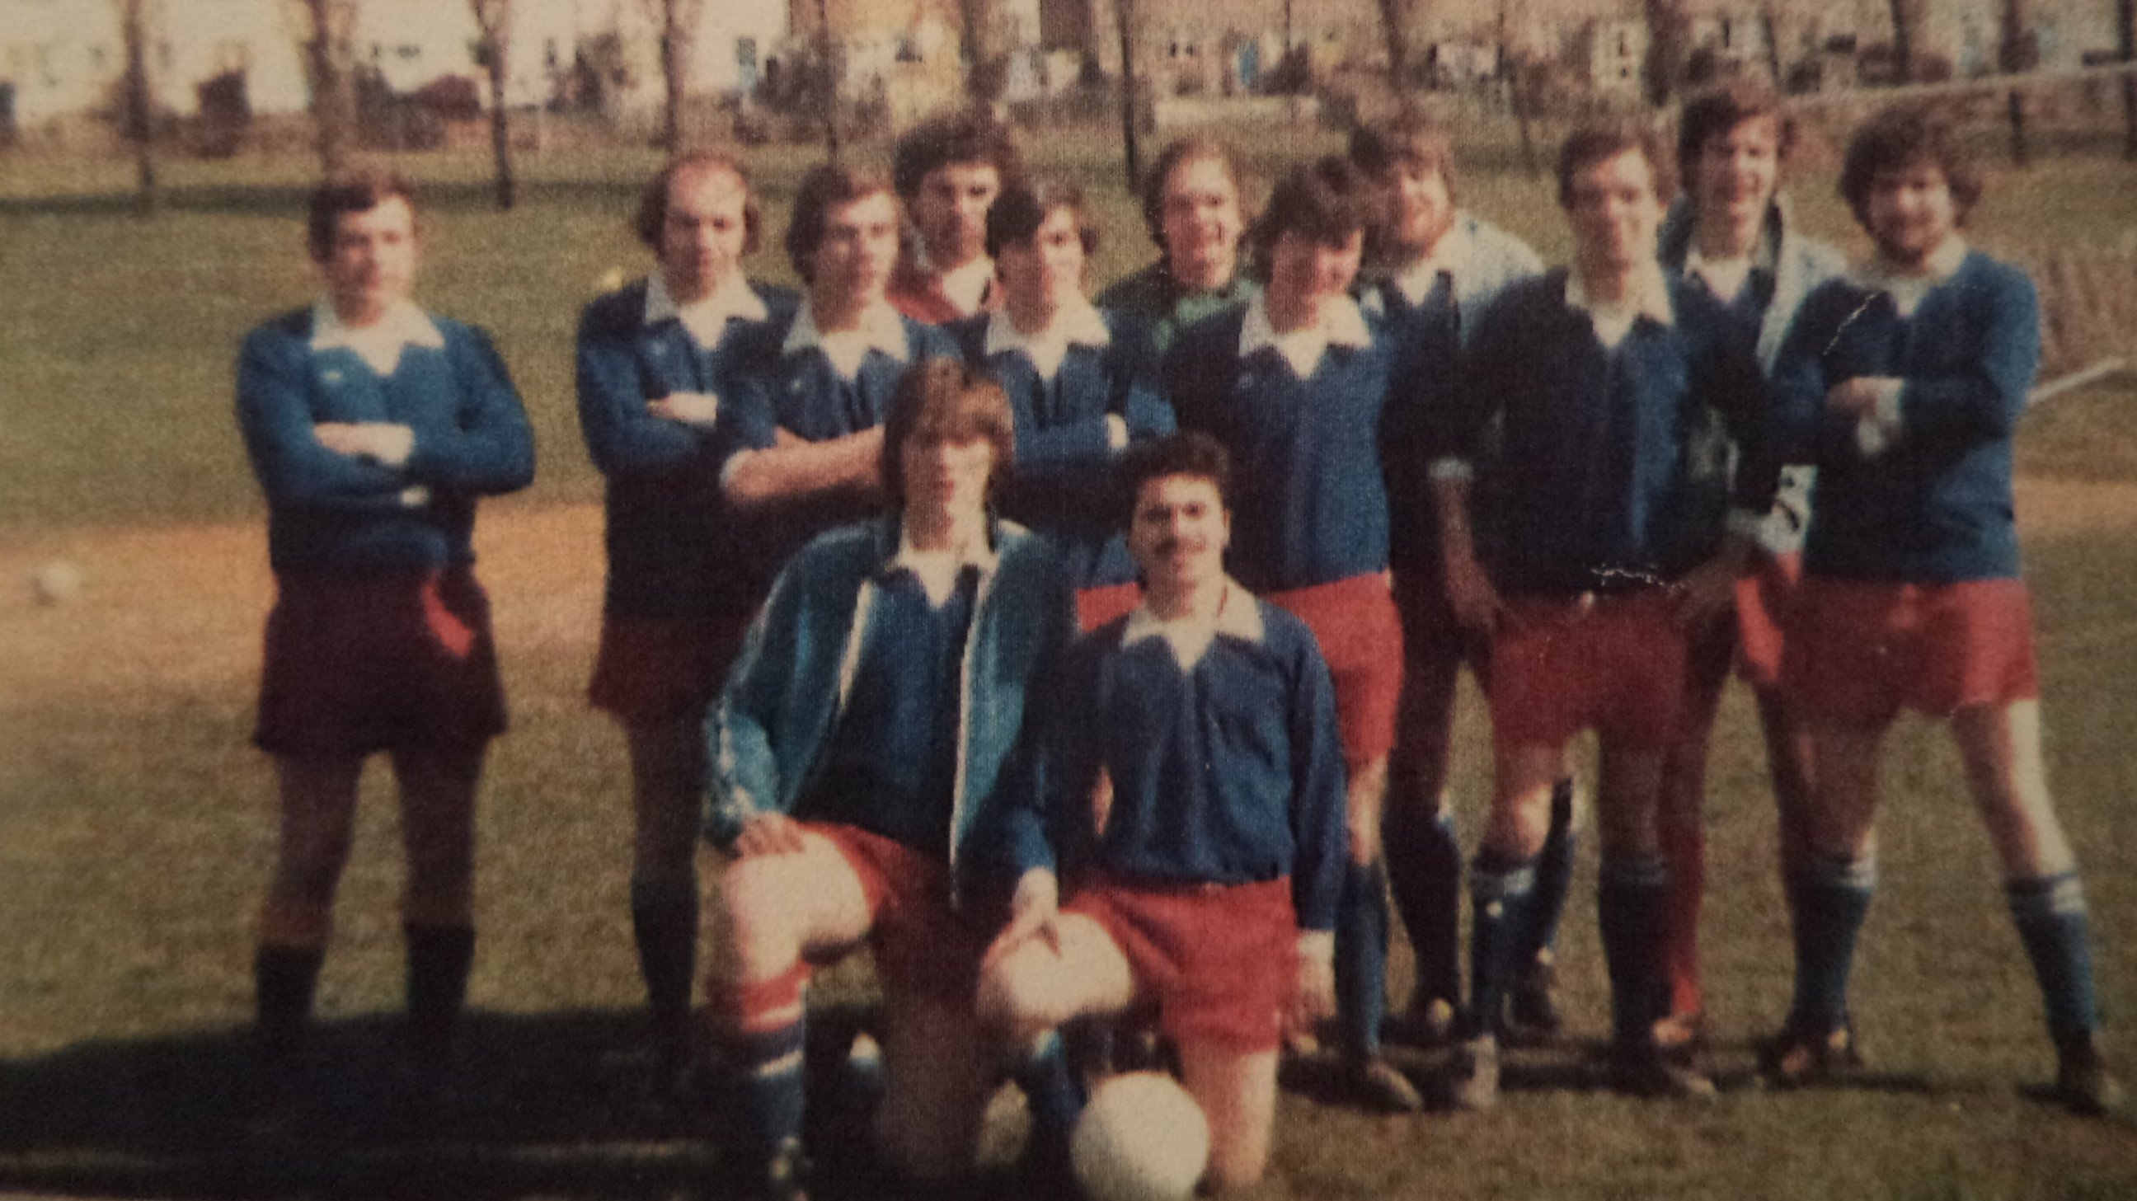
Len Franklin 4 0

L-R Back: John Purdy, Terry Bellinger, Sabino Favorito, Paul Eustace, Luis Navarro, Ken Ridgway, Malcolm Hill, Colin Chandler, Bob James, Keith Foster, Len Franklin.
L-R Front: Gary West, Mickey Michalle

